***Assignment 1***

**Downloaded the Oracle VM Virtual Box.**

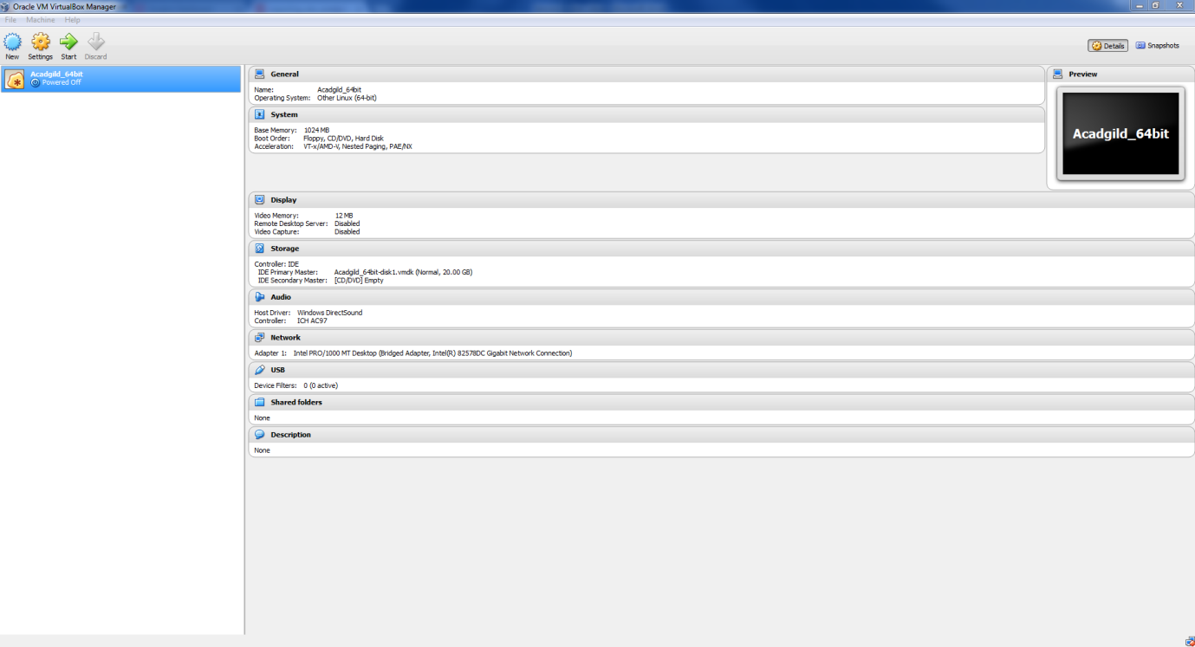

**And Imported Acadgild VM Image**

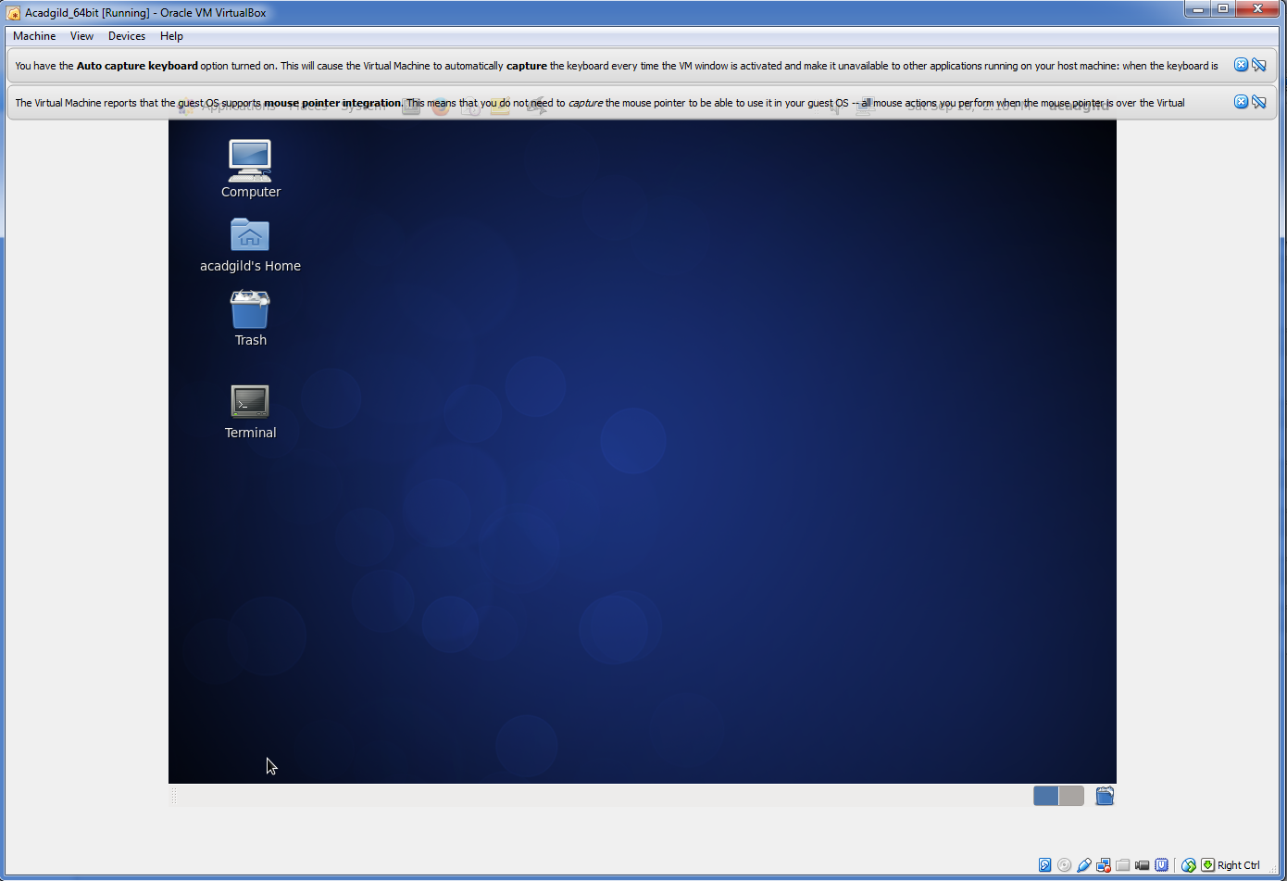

* **Checking the list of daemons**
* **Starting the ssh server**
* **Starting all daemons**
* **Starting the history server**

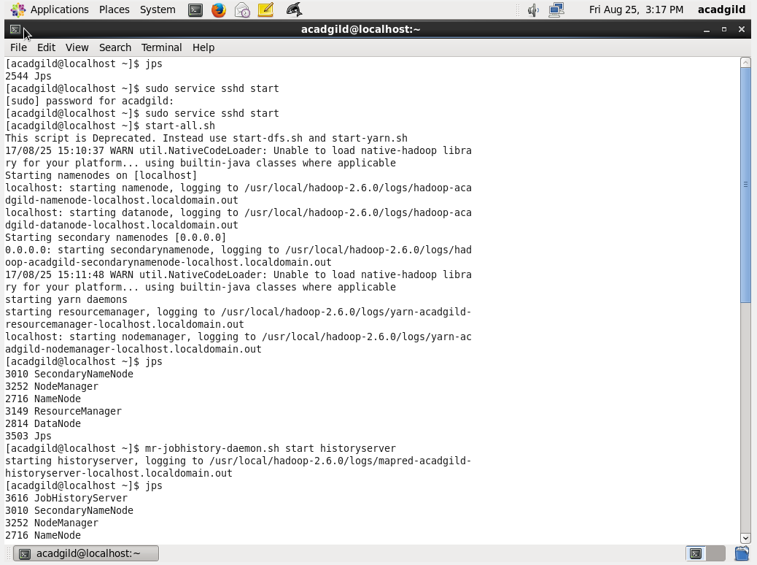

* **Starting PIG in HDFS mode**

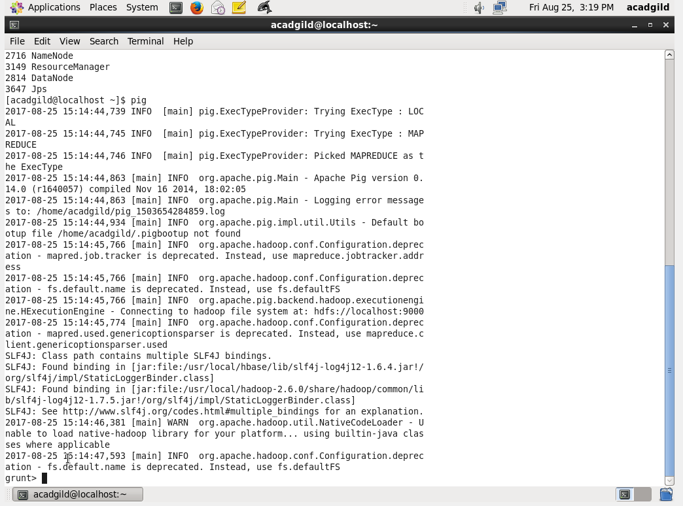

* **Starting mysql service and HIVE**

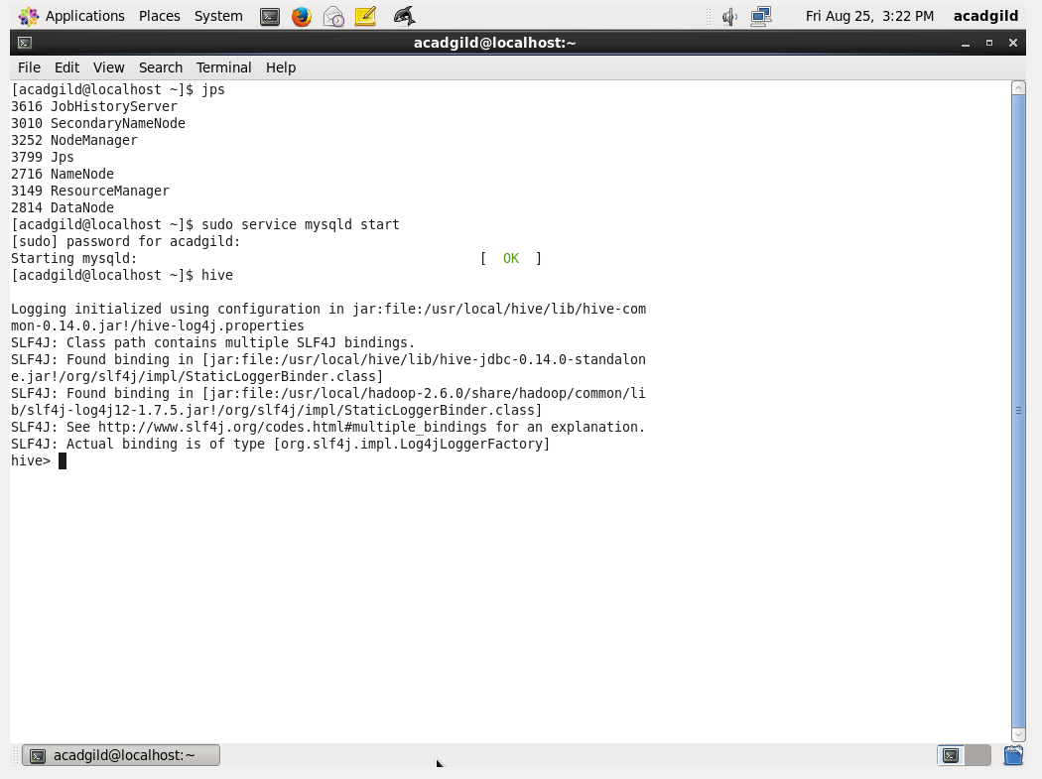

* **Starting HBASE**

